

Research Officer’s Annual Report
January – December 2006

Dr Pierre Pistorius

1. Introduction………………………………………………………………………….

2. Turtle monitoring……………………………………………………………………
2.1 Track counts along external beaches (Green turtles)……………………
2.2 Track counts along lagoon beaches (Hawksbill turtles)…………………
2.3 Tagging of nesting turtles………………………………………………….
2.4 Tagging of juvenile turtles…………………………………………………

3. Aldabra Tortoise monitoring………………………………………………………..
3.1 Introduction…………………………………………………………………
3.2 Grand Terre…………………………………………………………………
3.3 Malabar & Picard…………………………………………………………..
3.4 Aldabra population (total numbers)………………………………………

4. Bird monitoring………………………………………………………………………
4.1 Land birds…………………………………………………………………..
4.2 Wader counts ………………………………………………………………
4.2.1 Wader counts at Picard and Grand Terre……………………………..
4.2.2 Crab Plover Count……………………………………………………….
4.2.3 Flamingo sightings……………………………………………………….
4.4 Vagrant bird sightings……………………………………………………...

5. Subsistence fishing…………………………………………………………………..
6. Robber crabs…………………………………………………………………………
7. Marine mammals..………………………………………………………………….
8. Climate……………………………………………………………………………….
9. References……………………………………………………………………………

LIST OF FIGURES

Fig. 1. Location of beaches around Aldabra that are monitored for green turtle nesting activity. The circled figures indicate the number of nesting green turtles encountered on the respective beaches in 2006.
Fig.2. Mean number of green turtle tracks per day over the entire year at Settlement beach for the period 1999-2006.
Fig. 3. Average daily very fresh green turtle track counts on Settlement beach for 2006 (beach 47). 95% Confidence intervals are provided.
Fig. 4. Average daily very fresh green turtle turtle track counts on Settlement beach for the period 1999 to 2006 (beach 47).
Fig. 5. Mean number of green turtle tracks per day over the entire year at West Grand Terre (beaches 1-21) for the period 2000-2006.
Fig. 6. Average daily very fresh green turtle turtle track counts on West Grande Terre beaches (beach 1-21) for the period 2000 to 2006.
Fig. 7. Average daily very fresh green turtle track counts on West Grande Terre beaches for 2006 (beaches 1-21). 95% Confidence intervals are provided.
Fig 8. Location of beaches that are monitored for Hawksbill turtle nesting activity.
Figure 9. The location and relative length of tortoise transects around the Atoll (from Bourne & Goodridge 2004).
Fig. 10. Vegetation map of Aldabra (from Gibson & Phillipson 1983).
Fig 11. Population numbers of giant tortoises on Grande Terre (1998-2006).
Fig 12. Population numbers of giant tortoises on Malabar (1998-2006).
Fig. 13. Population numbers of giant tortoises on Picard (1998-2006).
Fig. 14. Total population numbers of giant tortoises on Aldabra for the period 1998-2006 and excluding the small Ile of Polymnie.
Fig. 15. Trends in land bird counts between 2002 and 2006.
Fig. 16. Trends in land bird counts between 2002 and 2006 (continue).
Fig. 18. Total weight of trawl fish caught at various locations around Aldabra in 2006.
Fig. 19. Total weight of bottom fish caught at various locations around Aldabra in 2006.
Fig 20. Monthly rainfall measured at the research station on Aldabra for 2006 and the average of measurements taken between 2000 and 2005.
Fig 21. Total annual rainfall at the research station on Aldabra for the period 2000-2006.
Fig. 22. Total annual rainfall recorded at Aldabra station between 1950 and 2001. The 1949-1984 dataset was obtained from Aldabra revisited (ERGO 1997) and the 1994-2001 dataset from records on Aldabra.
Fig. 23. Annual rainfall figures for the 12 rainfall gauges around Aldabra Atoll and at the research station for 2006.
Fig. 24. Mean monthly dry bulb temperatures at Aldabra station for 2006.

LIST OF TABLES

Table 1. Number of monthly green turtle track counts at various localities around Aldabra during 2006.
Table 2. The number of turtles handled in 2006 at Aldabra.
Table 3. Counts of shorebirds on Picard (Settlement Beach) and Grand Terre (Dune Jean-Louis to Dune d’Messe) for 2006. “-“ indicates no count made during that month.
Table 4. Counts of crab plovers around Aldabra during November and December 2006. Figures in italics give estimates based on prior knowledge rather than count estimates during the month.
Table 5. Sightings of greater flamingos at Aldabra during 2006.
Table 6. Sightings of vagrant birds at Aldabra during 2006.
Table 7. Total catch for 2006 of bottom and trawl fish by species at Aldabra.
Table 8. Mean monthly temperatures measured at Aldabra Station during 2006.

1. Introduction

I was appointed by SIF as Research Officer on the 15th of August and started my duties on Aldabra on the 9th of September after spending a few weeks in Mahe waiting for the departure of the supply boat. Bruno Bautil, the previous Research Officer, resigned in March and as head ranger Terence Mahoune has been filling in until my arrival. Despite only having spent a few months on the atoll I will attempt to give a run down of the most important monitoring data collected during the course of 2006. Where appropriate I will make inter-annual comparisons and place data collected in 2006 in a temporal context.

2. Turtle monitoring
2.1 Track counts along external beaches (Green turtles)

Track counts are most regularly performed on Settlement Beach (beach 47, Fig 1) due to its proximity to the research station and the suitability for green turtle nesting activity. Track counts have varied from 15 to 30 per month during the course of the year, and during the latter part of the year we have strived for daily counts (Table 1). It generally does not take much more than an hour to an hour and a half in the morning to complete. This effort is warranted as counts on this long section of beach are probably one of the best indicators of population status of green turtles at Aldabra. Beaches 1-22 on West Grande Terre (Fig. 1) have been visited between 2 and 7 times per month for track counts with 4 monthly visits being recommended. With the exception of February, track counts have been performed at least once a month on the North, South and East coast beaches.

Table 1. Number of monthly green turtle track counts at various localities around Aldabra during 2006.
 | Jan | Feb | Mar | Apr | May | Jun | Jul | Aug | Sep | Oct | Nov | Dec | Total
Settlement Beach | 15 | 15 | 21 | 23 | 25 | 26 | 22 | 17 | 26 | 29 | 29 | 30 | 278
West Grande Terre | 4 | 3 | 2 | 7 | 5 | 2 | 5 | 5 | 3 | 3 | 5 | 3 | 77
Cinq Cases beaches | 1 | 2 | 1 | 2 | 1 | 2 | 2 | 1 | 0 | 2 | 1 | 2 | 17
South Coast beaches | 2 | 0 | 1 | 1 | 1 | 1 | 1 | 1 | 1 | 1 | 1 | 1 | 12
North Coast beaches | 2 | 2 | 1 | 2 | 1 | 1 | 2 | 2 | 2 | 2 | 3 | 2 | 22

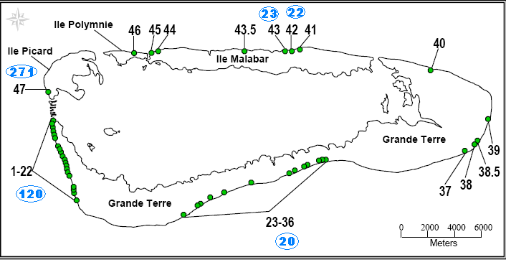
Fig. 1. Location of beaches around Aldabra that are monitored for green turtle nesting activity. The circled figures indicate the number of nesting green turtles encountered on the respective beaches in 2006.

On average during 2006 there were 9 to 10 very fresh (less than a day old) green turtle tracks counted per day along settlement beach (Fig. 2) stretching a distance of 1850 meters and making up about 50% of beach area available for nesting around the atoll. This is about a 20% higher frequency of emergences than have been reported annually since 1999 and 34% higher than 2005. Since these turtles only successfully nest every 1.5-3.2 emergences (Mortimer 1988) these figures do not imply similar increases in successful nesting occasions.

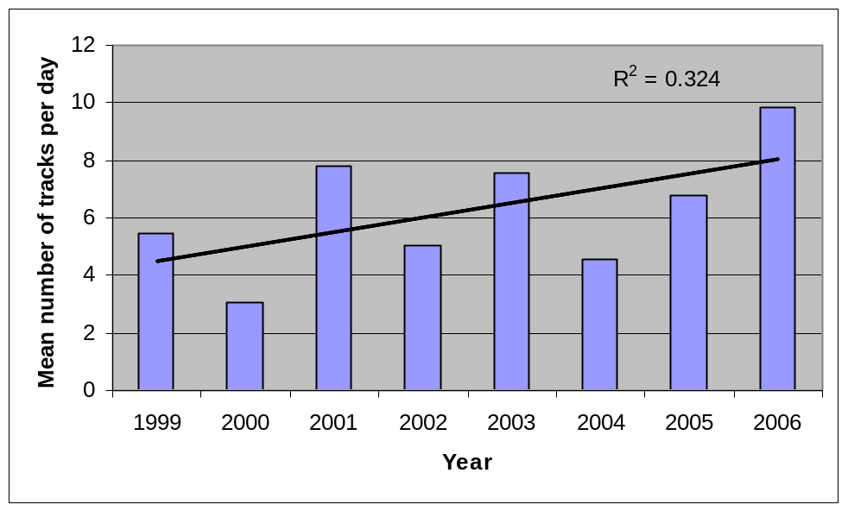
Fig.2. Mean number of green turtle tracks per day over the entire year at Settlement beach for the period 1999-2006.

Nesting activity at Settlement beach peaked during May and June (Fig. 3), a period when activity in previous years were declining (Fig. 4). During most previous years (1999-2005) nesting activity peaked during March and April (Fig. 4).

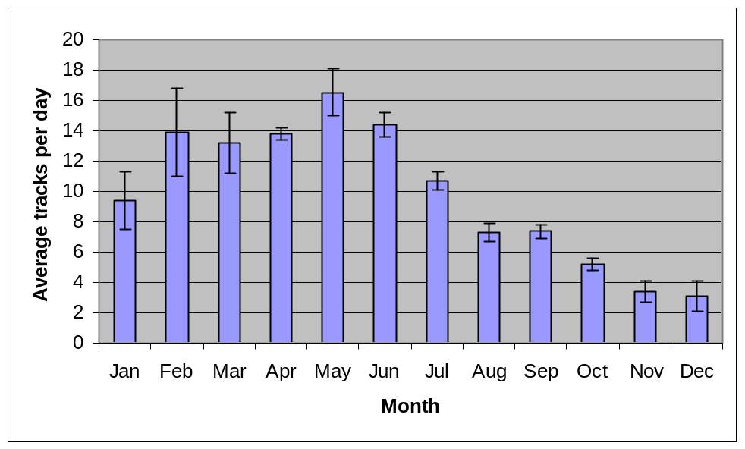
Fig. 3. Average daily very fresh green turtle track counts on Settlement beach for 2006 (beach 47). 95% Confidence intervals are provided.

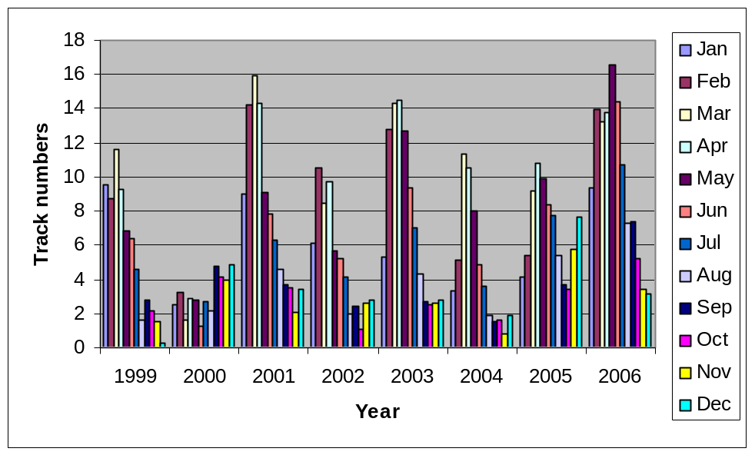
Fig. 4. Average daily very fresh green turtle track counts on Settlement beach for the period 1999 to 2006 (beach 47).

Second to Settlement beach, the 21 beaches on West Grand Terre are the most consistently monitored. Except for 2001, 2006 showed the most green turtle emergences since 2000 at West Grand Terre. It is worth noting that the high daily average emergences reported for this area in 2001 is largely a result of the high average for the month of June (90) which was based on two counts (Fig. 6). The fact that the June average for the same year at Settlement beach (based on 16 counts) is relatively low (Fig. 4) may suggest some form of bias in the June estimate at West Grand Terre. The figure of 35 average daily emergences in 2001 (when excluding the very high June estimate and using average June estimates for remaining years) may be more appropriate than the 42 presented in Fig. 5 which would imply that 2006 saw the most nesting activity since the turn of the decade at both Settlement beach and West Grande Terre.

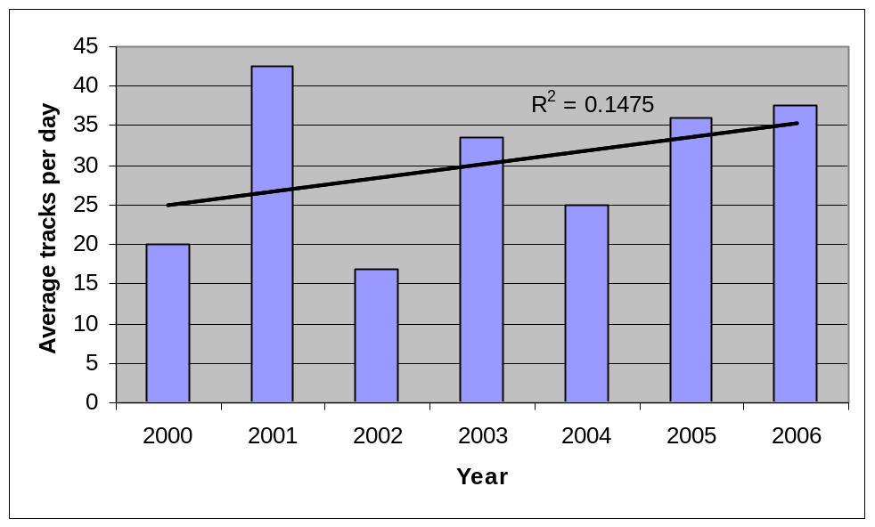
Fig. 5. Mean number of green turtle tracks per day over the entire year at West Grand Terre (beaches 1-21) for the period 2000-2006.

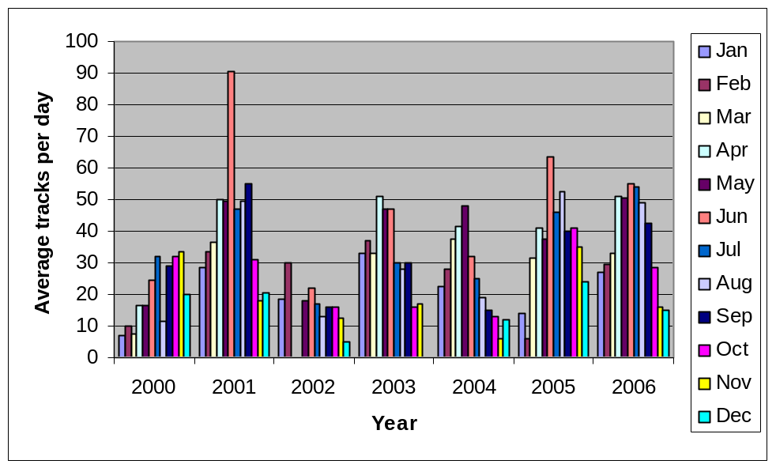
Fig. 6. Average daily very fresh green turtle track counts on West Grande Terre beaches (beach 1-21) for the period 2000 to 2006.

Seasonal activity patterns were similar at the two locations (Settlement beach and West Grand Terre) although it peaked one month later at West Grand Terre (June rather than May) and was relatively high here in July, August and September (Figs. 3 & 7).

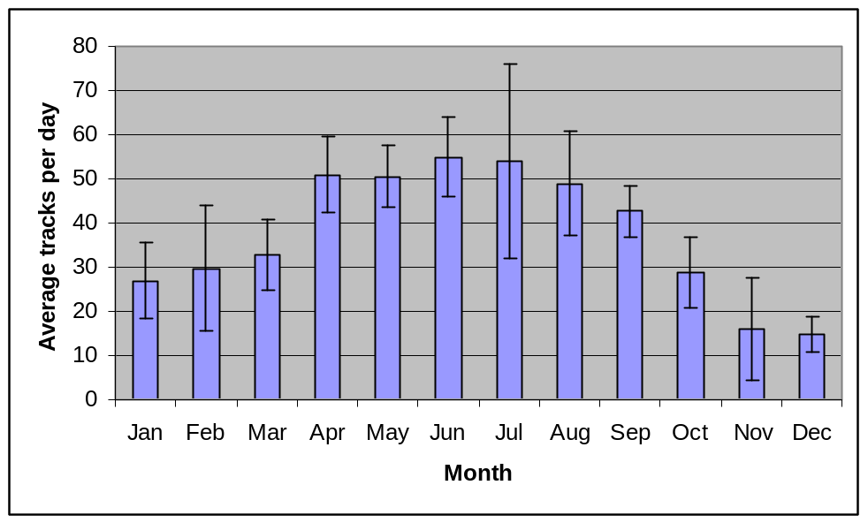

Fig. 7. Average daily very fresh green turtle track counts on West Grande Terre beaches for 2006 (beaches 1-21). 95% Confidence intervals are provided.

2.2 Track counts along lagoon beaches (Hawksbill turtles)

Hawksbill turtles occasionally nest on the lagoon beaches. Breeding activity is primarily restricted to the period September to March and during this time attempts are made to check beaches on a monthly basis. Fig.8 shows the beaches that have been monitored in the past. During 2006, beaches 51 to 53 were not checked for tracks. Beach 52 is obsolete and time-constraints when getting to and from Cinq Cases camp generally does not allow for an inspection of beach 53. There is currently no nesting platform on Ile Moustique (beach 50 –South Easterly Island of the two making up 50) and only sand flats that get flooded with spring tides. A total of 16 hawksbill turtle tracks were recorded in 2006 on the monitored beaches, mostly within the above-mentioned period.

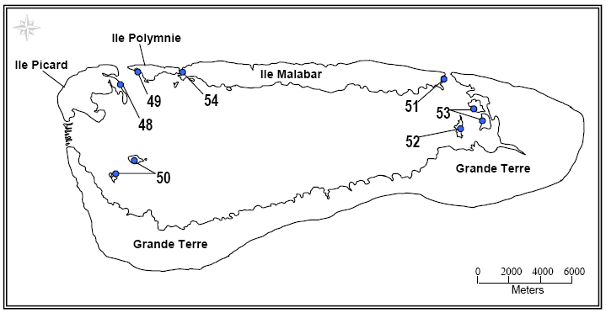
Fig 8. Location of beaches that are monitored for Hawksbill turtle nesting activity.

2.3 Tagging of nesting turtles

Tagging of nesting green turtles at settlement beach is scheduled between three and four times a month in the evenings. Monthly, two nights are spent at Anse Mais (West Grande Terre) during which tagging also takes place. Likewise, when at camp at other huts, evening tagging takes place. On encounter during track counts turtles are also tagged. A total of 456 nesting green turtles were encountered on all the beaches on Aldabra during the course of the year (Fig. 1, Table 2).

Three Hawksbill turtles were encountered on lagoon beaches and one of these was tagged on encounter. Unlike green turtles these turtles also nest during the day.

Table 2. The number of turtles handled in 2006 at Aldabra.
 | Total handled | Total tagged | Total old tags
Nesting green turtles | 456 | 326 | 130
Nesting hawksbill turtles | 1 | 1 | 1
Juvenile green turtles | 144 | 97 | 47
Juvenile hawksbill turtles | 32 | 27 | 5

2.4 Tagging of juvenile turtles

In water turtle activities, commonly referred to as “Rodeo” as it involves chasing turtles by boat until they are tired and then jumping on them, takes place between four and five times a month. Activities are mostly around Ile Moustique, Ile Esprit and the area around Bras Deux Cedres (in the proximity of beaches 50 on Fig. 8). Morphometric measurements are taken and individuals are weighed and tagged (if not already tagged). This is part of a unique study and one of the primary aims is to obtain reliable estimates of growth in both green and hawksbill turtles.

During 2006, 144 juvenile green turtles were captured of which about 33% were already tagged and proved data on growth rates (Table 2). About 16% of the 32 hawksbill turtles that were captured had tags. The majority of the turtles were captured at Ile Moustique. The shallow, clear water and sandy conditions around this lagoon island are favorable for rodeo activities.

3. Aldabra Tortoise monitoring
3.1 Introduction

The Aldabra Giant land tortoise is probably the epitome of Aldabra. It is the largest remaining population of giant land tortoises and close monitoring of the different subpopulations on the respective islands on Aldabra is a top priority. Since 1998, attempts have been made to sample 12 transects over the atoll (Fig. 9) on a monthly basis.

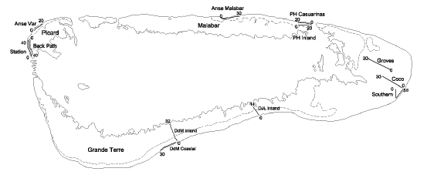
Figure 9. The location and relative length of tortoise transects around the Atoll (from Bourne & Goodridge 2004).

These transects were set out to represent the different vegetation types on Aldabra (Fig 10, Gibson 1983). David Bourn was contracted by SIF to design a model for the Aldabra tortoise population to facilitate entry of data collected from these transects and to generate automated population estimates. In essence, what is needed to do this is information about tortoise numbers per unit area in each vegetation type and total land area covered by each vegetation type. The former can be derived from the transect counts (although major seasonal changes in density have to be taken into account) and the latter was calculated from Gibson’s vegetation map (Fig. 10). Relatively simple arithmetic is then used to estimate total tortoise numbers in each vegetation type on the respective islands. For more details please see Bourn & Goodridge (2004).

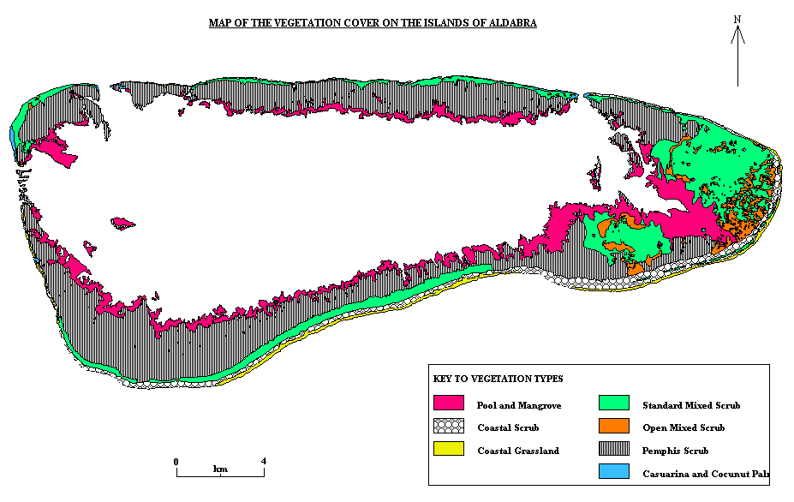
Fig. 10. Vegetation map of Aldabra (from Gibson & Phillipson 1983).

Rainer Von Brandis (a previous Research Officer) designed a similar self analyzing database (apparently unaware that David Bourn was in the process of doing so), the main difference being that his model did not estimate population numbers but used tortoise counts alone along the transects to generate trends. There are limitations and questionable assumptions in both models (see Borne & Goodridge 2004, Rainer Von Brandis 2003 annual RO report) but as population numbers may be of more interest to the readers of this report I will present estimates from Bourn’s model. The population estimation module of Bourn’s model has not functioned since 2004 but was recently repaired by Frances Taylor.

3.2 Grand Terre

Grand Terre is by far the largest of the four islands making up Aldabra at some 11 650 ha (excluding areas covered by mangrove). There are 6 transects on Grande Terre covering the respective vegetation types (Fig 9). The total number of tortoises on Grande Terre during 2006 is estimated at 92 857 individuals. At a density of about 8 individuals per hectare, there is more than a five fold higher number per unit area here than on Malabar or Picard. It is commonly regarded that density dependent competition for food resources is reason for these tortoises being smaller than their counterparts on the other islands.

Two transects fall within the “coastal grassland” vegetation type, the southern transect in east Grand Terre and the Dune D’Messe coastal transect. The former start about 10 meters from the Cinq Cases hut and runs straight past the hut. Tortoises congregate in large numbers around the hut and they feed on the left-over food and utilize the shade provided by the hut. There are also large numbers of well established trees (Guettarda speciosa) close to the hut providing suitable cover for tortoises that the transect pass by. The high number of tortoises recorded over the first few points of this transects is therefore very unlikely to be representative of the “coastal grassland” vegetation type as a hole and might cause some positive bias in the population estimate. In the last transect, for example, 31 individuals were counted within the first 150 meters (starting from the hut) and 24 in the remaining 950 meters before the transect turns inland. A limitation of the population estimation procedure is that it is based on the assumption that the very small percentage of area sampled is representative of the whole. A possible means to reduce such potential bias as mentioned above would be to change the first three points of this transect (currently running down towards the coast from the hut) so that they start parallel and next to the coast (starting further east).

The population at Grande Terre has been increasing since 1998 (Fig. 11) after a long term decline between the period 1973 and 1997 (Bourn et al. 1999). Although the linear regression in Fig. 11 accounted for almost half the variation in the population estimates since 1998 (R²=0.43) a T Test showed that the increase in population size over time was not significant (p=0.056). Note that this statistic was marginal as a p value of less than 0.05 would have implied significance (or a slope of non-zero).

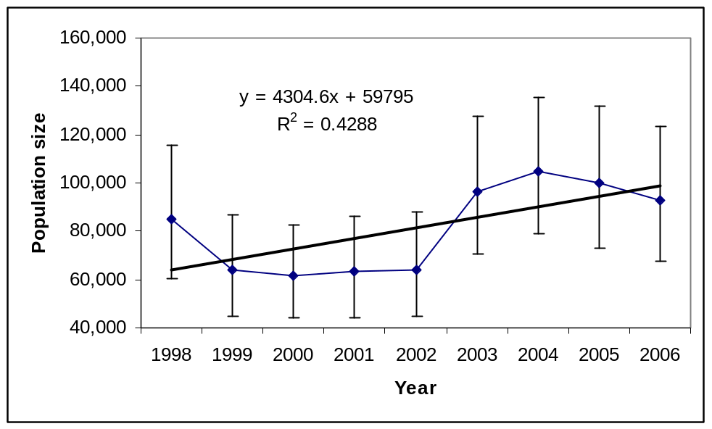
Fig. 11. Population numbers of giant tortoises on Grande Terre (1998-2006).

3.3 Malabar & Picard

Both the smaller populations of tortoises on Malabar and Picard make up less than 5% of the total Aldabra population. At least up to 1997, it has been argued that these populations have not yet reached levels where they are being regulated by density dependence (Bourn et al. 1999). The increase in the population that was recorded between 1973 and 1997 has continued at Malabar for the period 1998 to 2006 as is evident from Fig. 12. This increase in numbers at Malabar is highly significant (p=0.001). This population currently numbers some 3550 individuals.

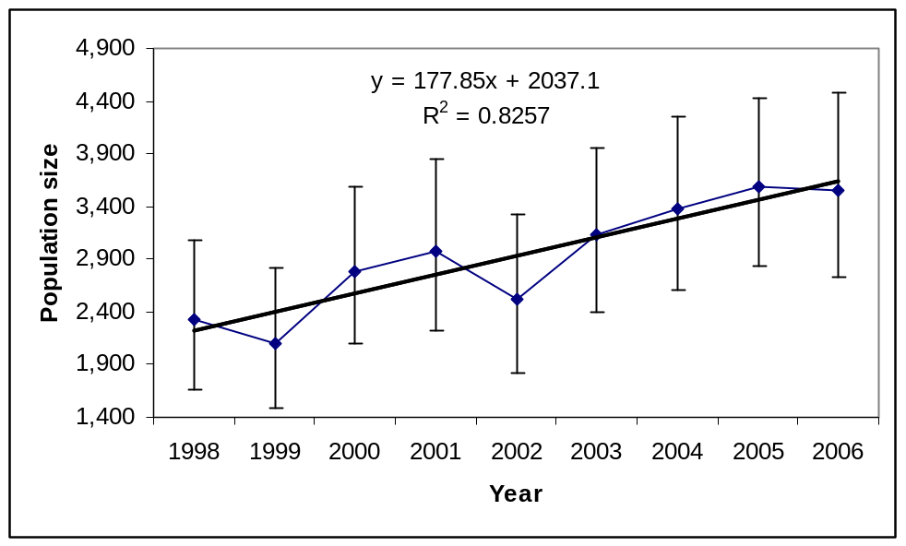
Fig. 12. Population numbers of giant tortoises on Malabar (1998-2006).

The small population at Picard represents less that 1% of the total Aldabra population. Although there is no support for a linear increase in numbers between the period 1998-2006 (p=0.570) this is largely a result of low estimates in 2005 and 2006 (Fig. 13). Between 1998 and 2004 the population increased significantly (p= 0.001) but some obscure factor/s then caused a sharp decline in numbers. The fact that these low numbers are not reflected in the Malabar population suggests that this is not related to large scale environmental factors. Intrinsic factors such as density dependence is, however, also unlikely as Picard still have the lowest numbers per unit area.

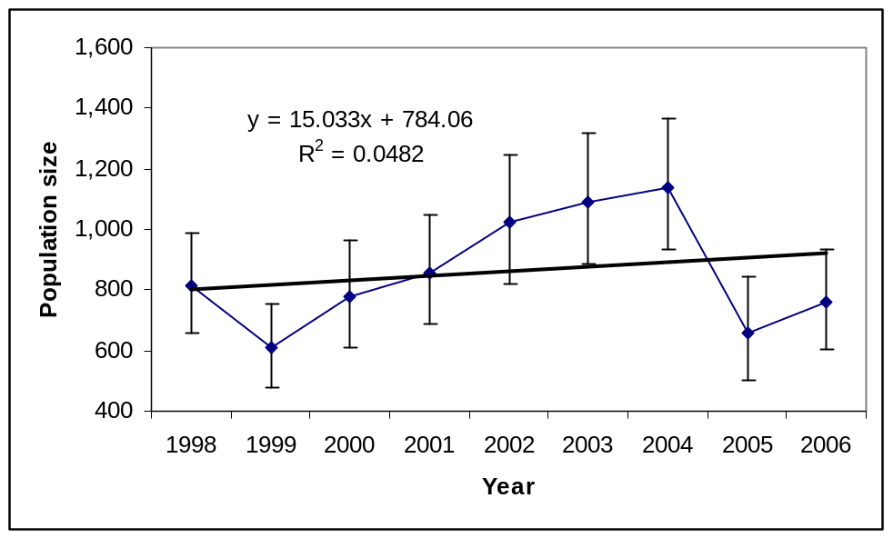
Fig. 13. Population numbers of giant tortoises on Picard (1998-2006).

3.4 Aldabra population (total numbers)

The total population size for Aldabra (excluding the small island of Polymnie and the small lagoon islands) is currently estimated at some 97 160 individuals. The population as a whole has demonstrated a significant linear increase between 1998 and 2006 (Fig. 14, p=0.048).

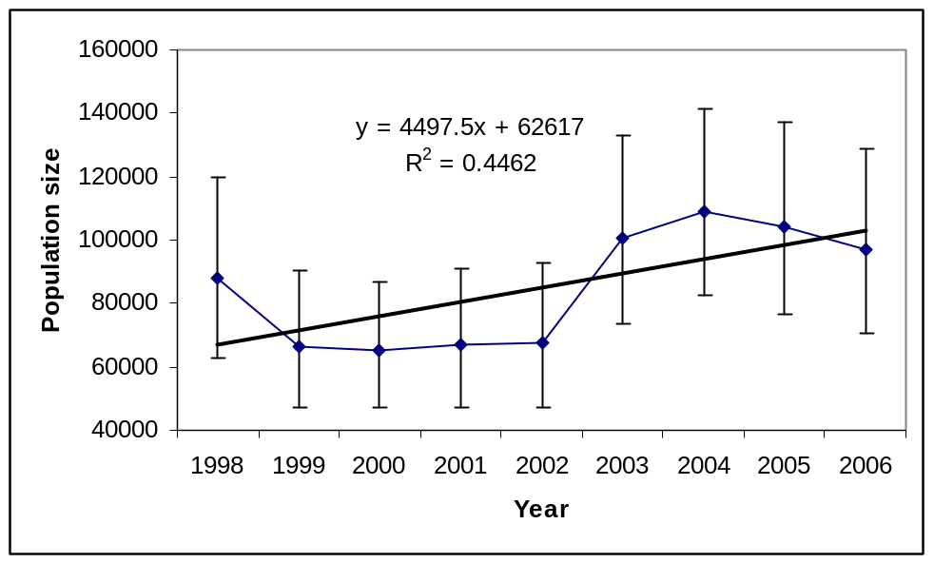
Fig. 14. Total population numbers of giant tortoises on Aldabra for the period 1998-2006 and excluding the small Ile of Polymnie.

4. Bird monitoring
4.1 Land birds

A land bird monitoring scheme was set up on Aldabra by Michael Betts in 1999 with some refinements made by Ross Wanless in 2000. All birds within a 25 meter radius at designated points along 7 of the tortoise transects are recorded over a four minute period. This is done by making use of both sightings and vocalizations. Data recorded in this manner since 2002 seem relatively consistent, covering most months with large gaps prior to this. The transects are as follows:

1. Station Backpath, Picard, 9 count points
2. Bassin Lebines trail, Picard, 5 count points
3. Dune Jean-Louis, Grande Terre, 4 count points
4. Cinq Cases Coco, Grande Terre, 8 count points
5. Cinq Cases Groves, Grande Terre, 8 point counts
6. Middle Camp Inland Traverse, Malabar, 6 count points
7. Dune d’Messe, Grande Terre, 9 count points

Below are figures of total annual counts from all the transects combined for the period 2002-2006. In years where counts were not performed during one or more months, average monthly counts were used to make the necessary adjustments.

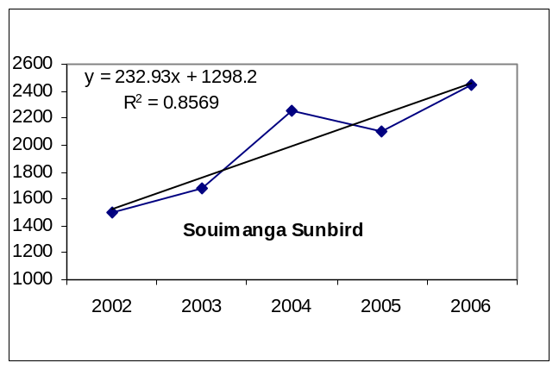
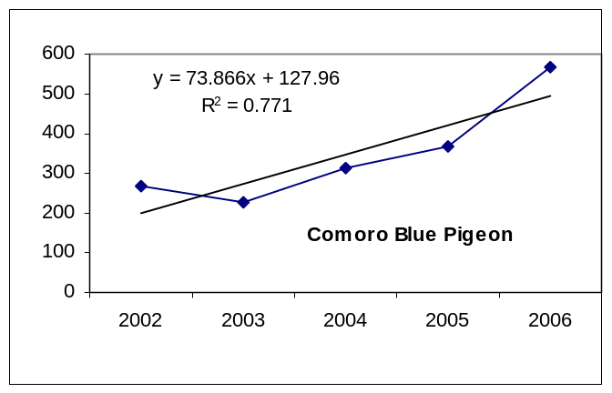
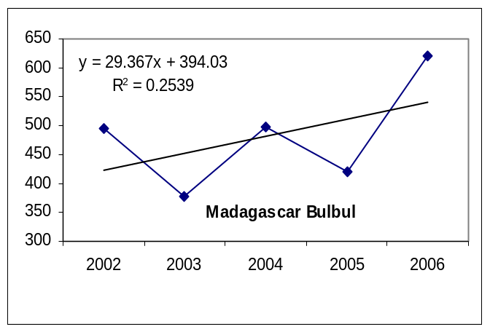
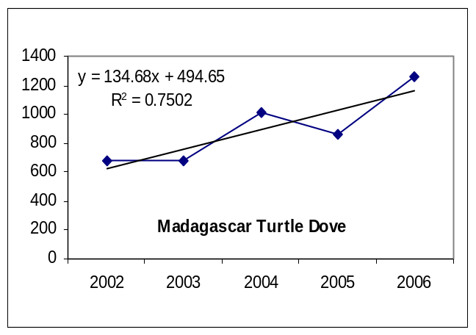
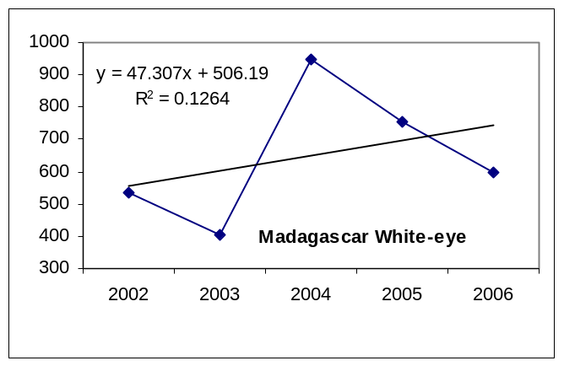
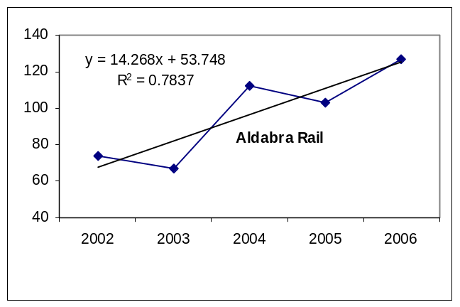
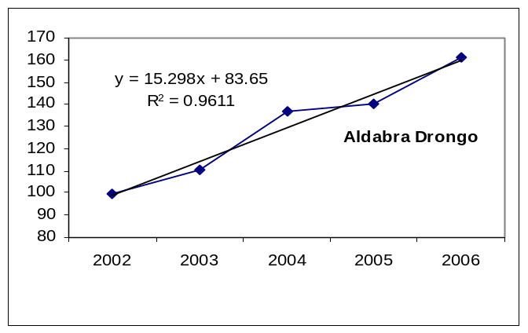
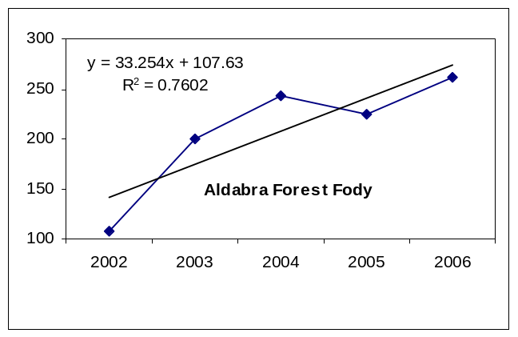
Fig. 15. Trends in land bird counts between 2002 and 2006.

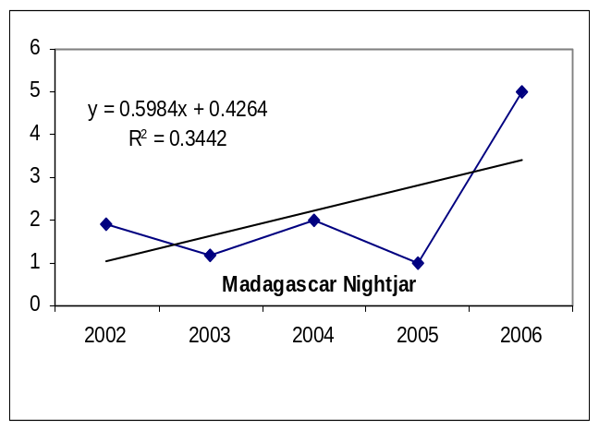
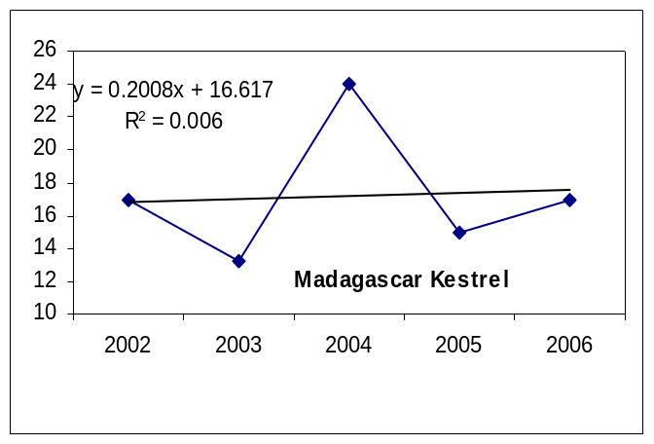
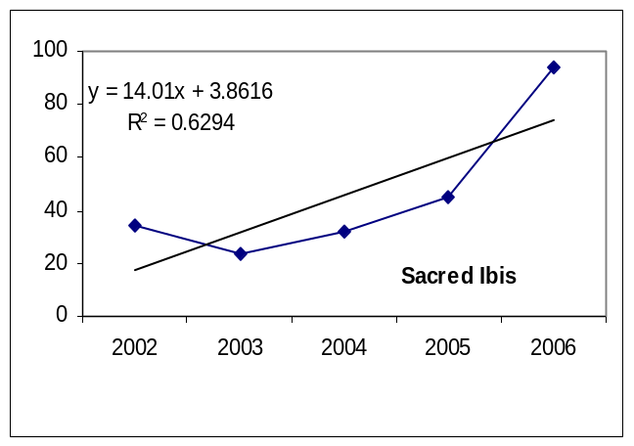
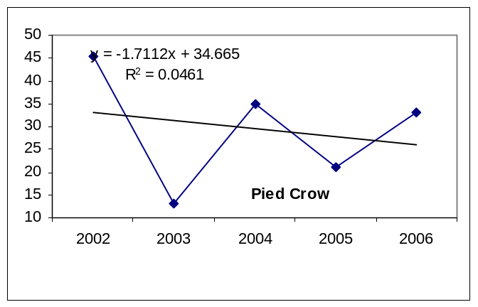
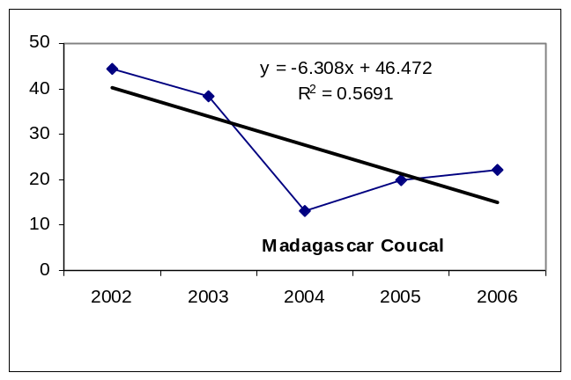

Fig. 16. Trends in land bird counts between 2002 and 2006 (continue).

Point count data collected for land birds over the past five years suggest an increase in numbers of most land birds over this period. During 2002, March, April and May counts were omitted from most locations and in 2003 November and December counts. Average monthly counts for the remaining months were used to provide estimates for the missing months and these were used to obtain total annual counts. Estimates for these months therefore rely on the assumption that birds are similarly distributed and visible throughout the year. The missing months largely correspond to the wet months when birds could be expected to be more visible as a result of increased activity patterns associated with breeding activities. Estimates for these two years could therefore be negatively biased. Very few counts were missed from 2004 onwards and estimates for these years should be directly comparable.

The Aldabra Forest Fody and Aldabra’s only endemic species, the Aldabra Drongo, showed a peak number in 2006. Similarly the Aldabra rail appears to be on the increase and this is largely a result of an increase in numbers seen on Picard. Although white eye numbers still appear slightly higher than in 2002 and 2003, numbers appear to have declined since 2004. It is worth noting that these birds are very gregarious and not evenly distributed, an attribute that is likely to contribute to variability in annual count estimates. Sunbird, Blue Pigeon, Turtle Dove, Bulbul and Sacred Ibis numbers also showed a record high in 2006. Although down from 2002 and 2003, Madagascar Coucal numbers seem to be steadily climbing. The low numbers reported, their cryptic nature and the difficulty associated with judging distance from their vocalization makes these estimates vulnerable to observer bias. Pied crows are seldom observed on these transects as they are often confined to areas very close to the coast. Estimates from point counts therefore serve poorly at determining population status of these birds.

A more detailed analysis of area-specific and seasonal count data is required to explain some of the trends observed here. The high rainfall in 2006 (see section on climate) may, however, have created a suitable environment for landbirds during this year thereby maximizing recruitment and/or survival which resulted in high population numbers.

4.2 Wader counts
4.2.1 Wader counts at Picard and Grand Terre

Monitoring of waders in terms of counts along Settlement beach at Picard and the coastal stretch between Dune Jean-Louis and Dune D’Messe commenced in 2003. These counts are always performed during low tide when the reef is exposed and are performed during most months on Picard (exception in 2006 being March and August). When the walk between Dune Jean-Louis and Dune D’Messe does not correspond to low tide then counts are restricted to roosting sites close to the dunes. From data collected in the past it is impossible to determine whether counts were made along the entire stretch or only at roosting sites. A new database (access rather than excel) has now been created which will allow the distinction to be made. Table 3 presents wader counts for 2006. A more formal treatment of the data will be presented to SIF in the near future as Frances Taylor has undertaken to write the wader count data up together with vagrant sightings for possible publication in 2007.

Table 3. Counts of shorebirds on Picard (Settlement Beach) and Grand Terre (Dune Jean-Louis to Dune d’Messe) for 2006. “-“ indicates no count made during that month.
Common name | Location | Jan | Feb | Mar | Apr | May | Jun | Jul | Aug | Sep | Oct | Nov | Dec | Avg | Total
Grey heron | Picard | 14 | 5 | - | 4 | 7 | 8 | 7 | - | 8 | 9 | 6 | 7 | 8 | 75
 | Grand Terre | 0 | - | 0 | 0 | 1 | 0 | - | 0 | 0 | 0 | 0 | 10 | 1 | 11
Green-backed heron | Picard | 14 | 6 | - | 7 | 11 | 21 | 19 | - | 13 | 8 | 9 | 6 | 11 | 114
 | Grand Terre | 0 | - | 0 | 0 | 3 | 0 | - | 1 | 0 | 0 | 0 | 8 | 1 | 12
Dimorphic egret | Picard | 89 | 139 | - | 99 | 25 | 21 | 17 | - | 70 | 138 | 96 | 115 | 81 | 809
 | Grand Terre | 0 | - | 0 | 5 | 3 | 1 | - | 9 | 0 | 7 | 0 | 14 | 4 | 39
Crab plover | Picard | 73 | 61 | - | 33 | 10 | 2 | 7 | - | 2 | 10 | 75 | 143 | 42 | 416
 | Grand Terre | 200 | - | 0 | 100 | 0 | 0 | - | 0 | 0 | 0 | 60 | 364 | 72 | 724
Lesser sand plover | Picard | 0 | 4 | - | 0 | 0 | 0 | 0 | - | 0 | 1 | 1 | 7 | 1 | 13
 | Grand Terre | 100 | - | 0 | 25 | 0 | 0 | - | 0 | 100 | 100 | 320 | 60 | 71 | 705
Greater sand plover | Picard | 2 | 0 | - | 0 | 0 | 0 | 0 | - | 6 | 5 | 0 | 1 | 1 | 14
 | Grand Terre | 300 | - | 250 | 35 | 0 | 0 | - | 150 | 100 | 100 | 0 | 100 | 104 | 1035
Sand plover (Total) | Picard | 2 | 4 | - | 0 | 0 | 0 | 0 | - | 6 | 6 | 1 | 8 | 3 | 27
 | Grand Terre | 400 | - | 250 | 60 | 0 | 0 | - | 150 | 200 | 200 | 320 | 160 | 174 | 1740
Grey plover | Picard | 4 | 3 | - | 0 | 0 | 0 | 0 | - | 12 | 3 | 2 | 1 | 3 | 25
 | Grand Terre | 0 | - | 2 | 0 | 0 | 0 | - | 2 | 20 | 0 | 0 | 0 | 2 | 24
Common ringed plover | Picard | 3 | 1 | - | 0 | 0 | 0 | 0 | - | 0 | 0 | 0 | 1 | 1 | 5
 | Grand Terre | 0 | - | 0 | 0 | 0 | 0 | - | 0 | 0 | 0 | 0 | 0 | 0 | 0
Bar-tailed godwit | Picard | 12 | 15 | - | 0 | 1 | 0 | 0 | - | 27 | 0 | 21 | 23 | 10 | 99
 | Grand Terre | 0 | - | 0 | 0 | 0 | 0 | - | 0 | 0 | 0 | 0 | 0 | 0 | 0
Whimbrel | Picard | 13 | 3 | - | 0 | 0 | 0 | 0 | - | 6 | 6 | 2 | 2 | 3 | 32
 | Grand Terre | 0 | - | 0 | 0 | 0 | 4 | - | 1 | 4 | 5 | 0 | 10 | 2 | 24
Common greenshank | Picard | 4 | 1 | - | 0 | 0 | 0 | 0 | - | 3 | 16 | 1 | 3 | 3 | 28
 | Grand Terre | 0 | - | 50 | 0 | 0 | 0 | - | 0 | 0 | 0 | 0 | 0 | 5 | 50
Common sandpiper | Picard | 0 | 0 | - | 0 | 0 | 0 | 2 | - | 0 | 0 | 0 | 0 | 0 | 2
 | Grand Terre | 0 | - | 0 | 15 | 0 | 0 | - | 0 | 0 | 0 | 0 | 5 | 2 | 20
Ruddy turnstone | Picard | 53 | 22 | - | 3 | 0 | 28 | 0 | - | 97 | 80 | 83 | 55 | 42 | 421
 | Grand Terre | 0 | - | 0 | 0 | 0 | 0 | - | 39 | 30 | 81 | 30 | 111 | 29 | 291
Sanderling | Picard | 5 | 15 | - | 0 | 0 | 0 | 0 | - | 3 | 0 | 5 | 22 | 5 | 50
 | Grand Terre | 0 | - | 0 | 0 | 0 | 0 | - | 0 | 0 | 0 | 0 | 0 | 0 | 0
Curlew sandpiper | Picard | 0 | 0 | - | 0 | 0 | 0 | 0 | - | 0 | 0 | 0 | 0 | 0 | 0
 | Grand Terre | 0 | - | 0 | 0 | 0 | 0 | - | 0 | 0 | 0 | 0 | 0 | 0 | 0
Greater crested-tern | Picard | 1 | 5 | - | 4 | 3 | 0 | 0 | - | 6 | 14 | 2 | 2 | 4 | 37
 | Grand Terre | 0 | - | 0 | 0 | 0 | 0 | - | 3 | 0 | 0 | 0 | 0 | 0 | 3
Lesser crested-tern | Picard | 2 | 0 | - | 0 | 0 | 3 | 0 | - | 0 | 0 | 0 | 0 | 1 | 5
 | Grand Terre | 0 | - | 0 | 0 | 0 | 0 | - | 0 | 0 | 0 | 0 | 0 | 0 | 0
Caspian tern | Picard | 0 | 0 | - | 2 | 0 | 2 | 3 | - | 0 | 0 | 0 | 0 | 1 | 7
 | Grand Terre | 0 | - | 0 | 2 | 3 | 0 | - | 6 | 0 | 0 | 0 | 0 | 1 | 11
Black-naped tern | Picard | 5 | 3 | - | 0 | 2 | 0 | 0 | - | 1 | 1 | 1 | 1 | 1 | 14
 | Grand Terre | 0 | - | 0 | 0 | 0 | 0 | - | 0 | 0 | 0 | 0 | 0 | 0 | 0
Brown noddy | Picard | 0 | 0 | - | 0 | 6 | 0 | 0 | - | 0 | 0 | 0 | 0 | 1 | 6
 | Grand Terre | 0 | - | 0 | 0 | 0 | 0 | - | 1 | 0 | 0 | 0 | 0 | 0 | 1
Total | Picard | 294 | 283 | 0 | 152 | 65 | 85 | 55 | 0 | 254 | 291 | 304 | 389 | 181 | 2172
 | Grand Terre | 600 | 0 | 302 | 182 | 10 | 5 | 0 | 212 | 254 | 293 | 410 | 682 | 246 | 2950

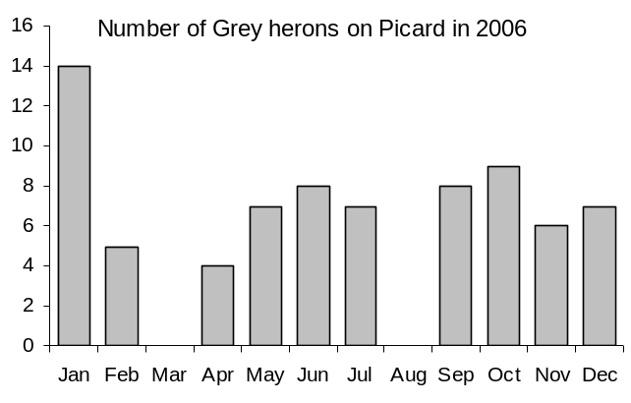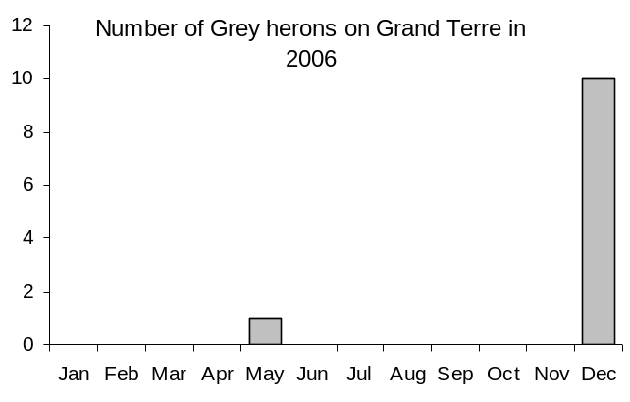
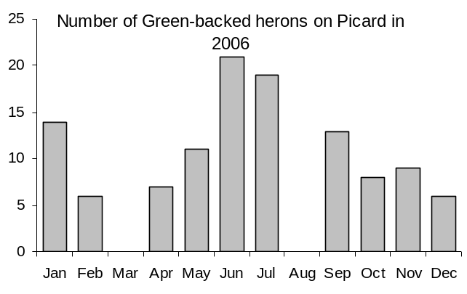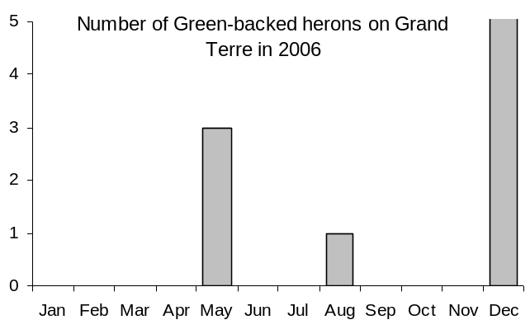
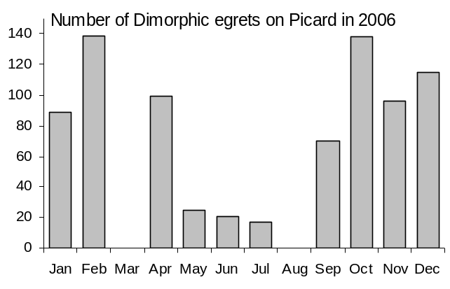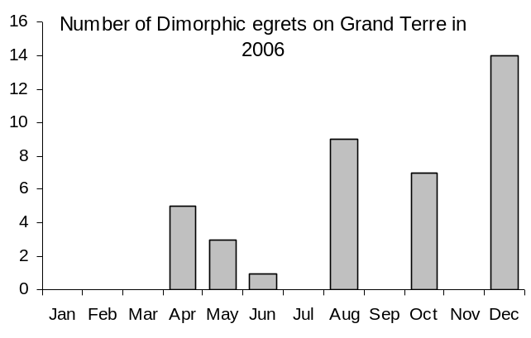
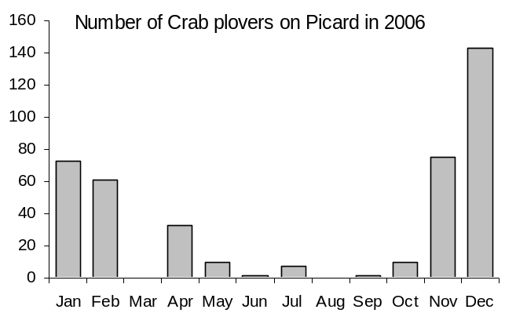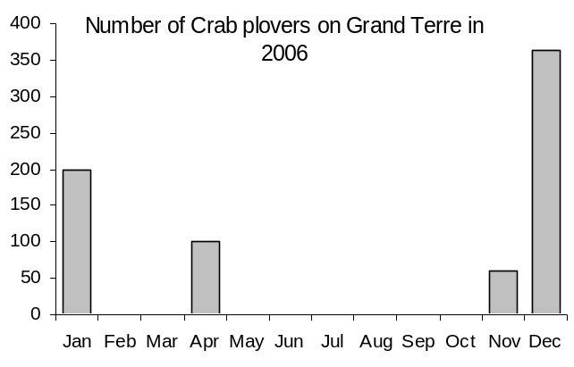
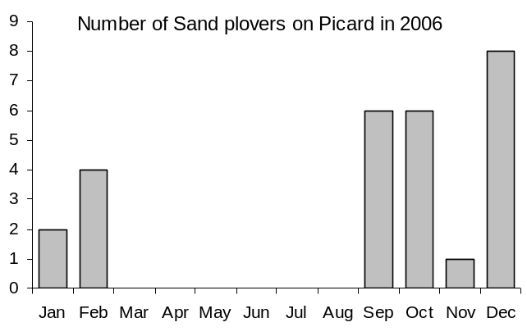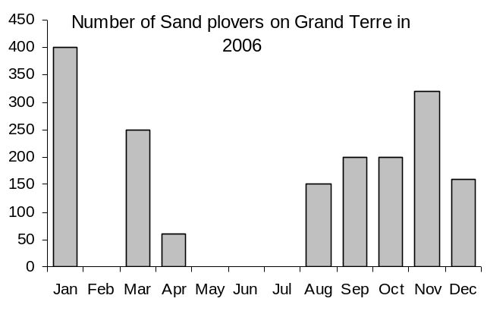
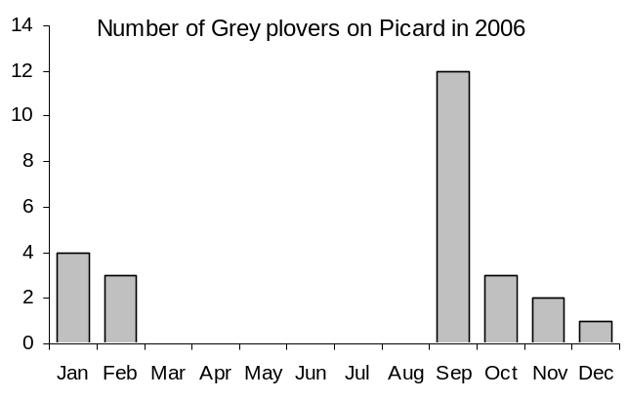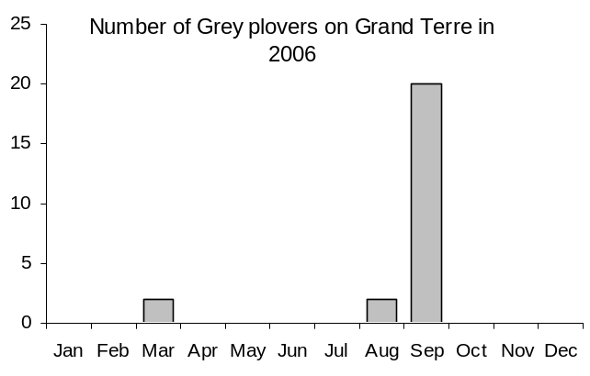
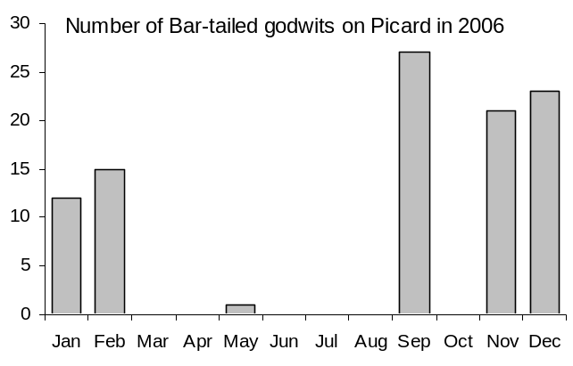
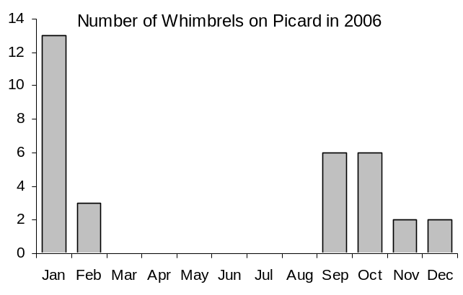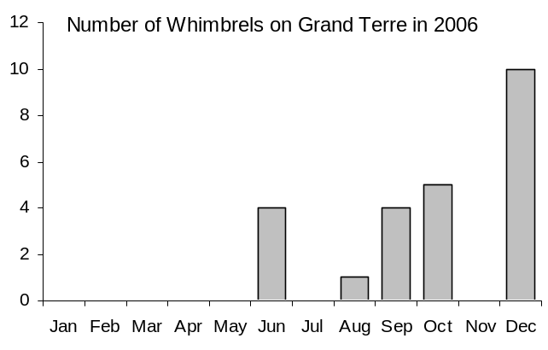
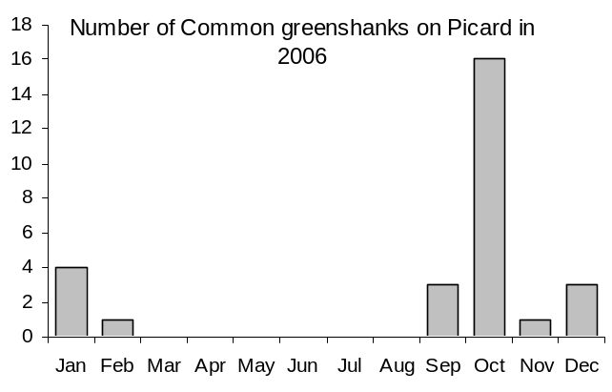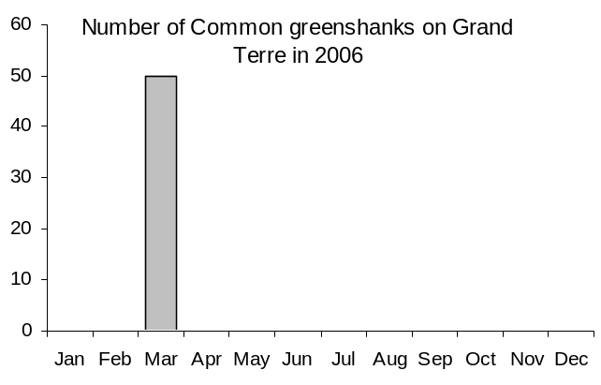
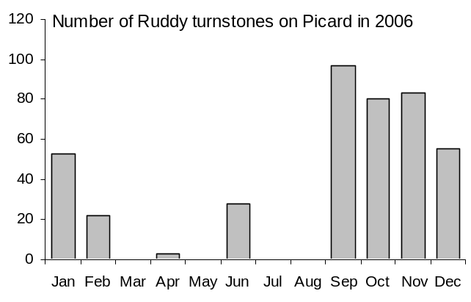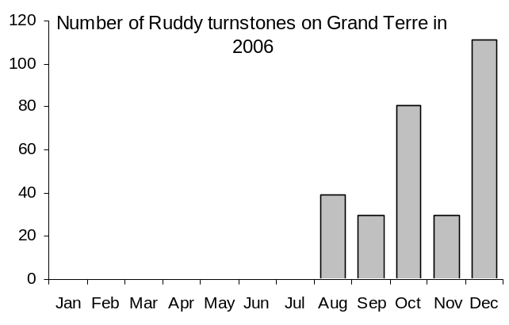
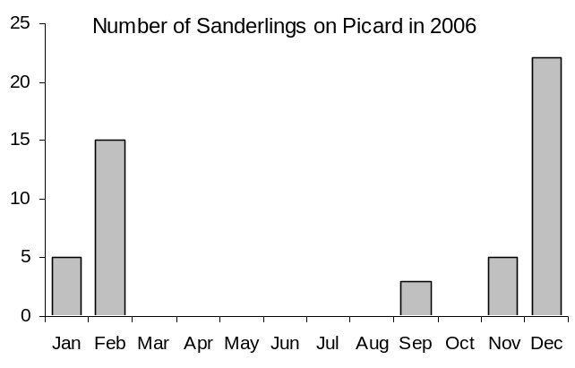
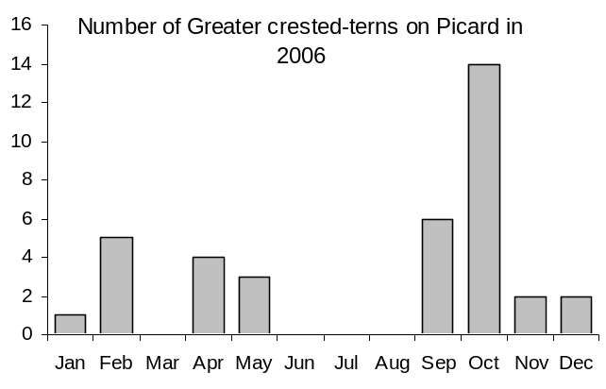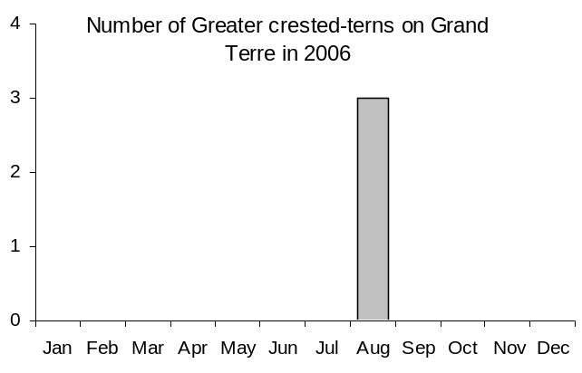
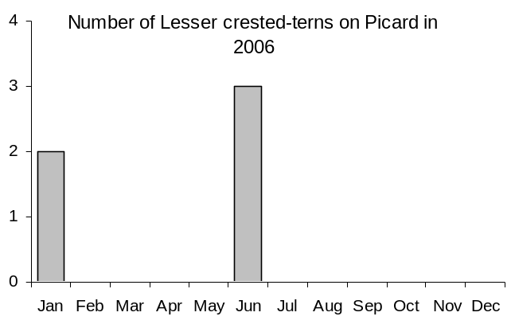
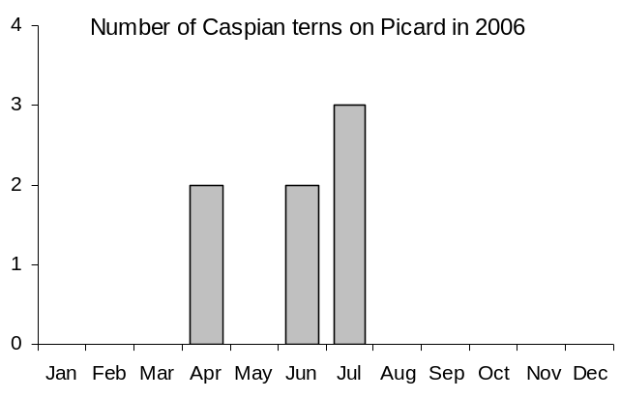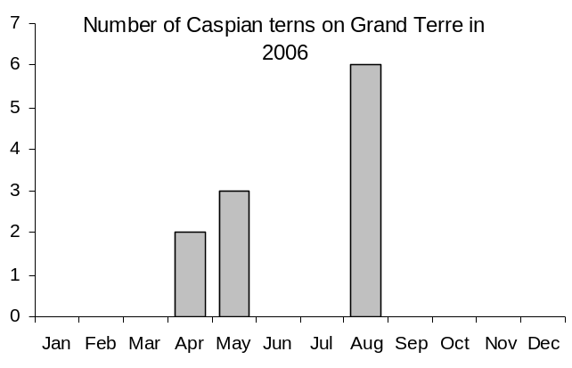
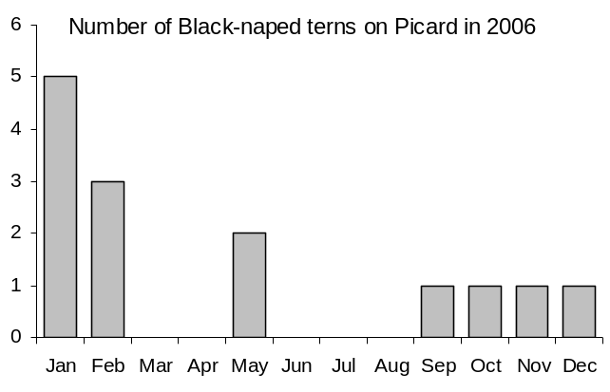

4.2.2 Crab Plover Count

A crab plover count was performed in both November and December and was justified by the importance of Aldabra as a breeding site for this unique species. In both months, as many areas as possible where crab plovers are known to roost were visited and counts were made (Table 4). As there is likely to be some movement between roosting areas, counts were performed within a period of two days. The most important roosting areas for crab plovers on Aldabra in order of importance are Ile Moustiques and Settlement beach. With high numbers here we photographed them as they flew up after being startled. They generally stick to tight groups which allow most of them to be captured in a series of photographs. Individuals were then counted from these by zooming in to the high resolution photographs (see below).
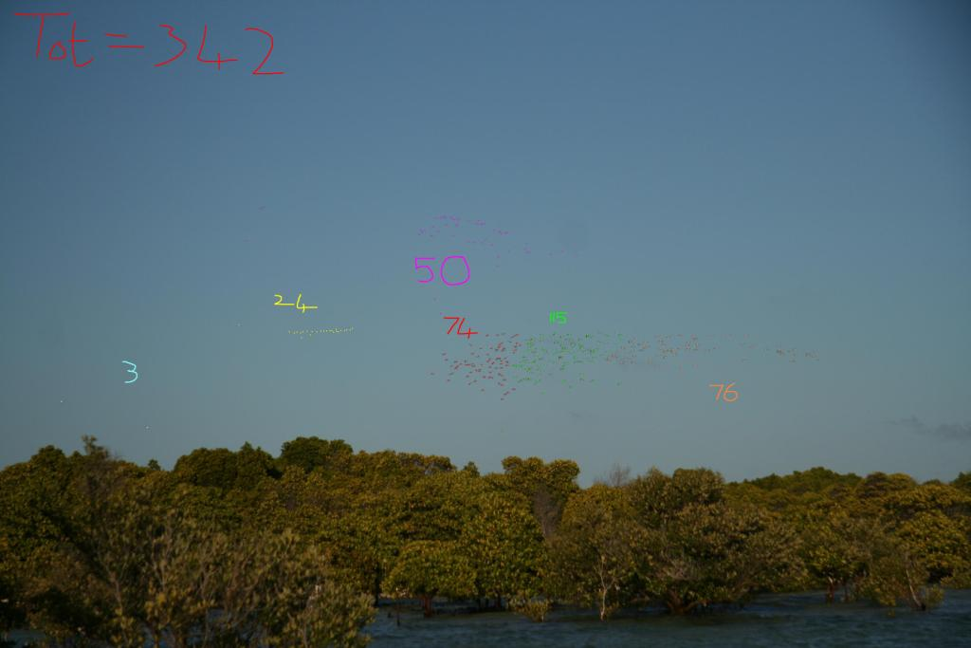

Both counts of 1216 and 2017 for November and December respectively are lower than the numbers reported from the previous count by Michael Betts in January 2000 which amounted to 2800 individuals. He included 500 individuals scattered throughout the lagoon that were not counted and not corresponding to areas included in our counts. The difference between our counts is not that large when including this speculative number into the recent counts.

Table 4. Counts of crab plovers around Aldabra during November and December 2006. Figures in italics give estimates based on prior knowledge rather than count estimates during the month.
Locality |  |  |  | Number | Date | Number | Date
La Gigi |  |  |  | 64 | 10-Nov | 43 | 07-Dec
Ile Moustiques |  |  |  | 664 | 10-Nov | 583 | 07-Dec
Grand Cavalier |  |  |  | 0 | 10-Nov | 0 | 07-Dec
Petit Cavalier |  |  |  | 0 | 10-Nov | 0 | 07-Dec
Settlement beach |  |  |  | 47 | 10-Nov | 551 | 07-Dec
Ilots west of Ile Michel |  |  |  | 346 | 09-Nov | 346
Dune Jean-Louis-D'Messe |  |  |  | 64 | 10-Nov | 364 | 06-Dec
Cinq Cases |  |  |  | 24 | 09-Nov | 80
North Coast |  |  |  | 7 | 09-Nov | 50
 |  |  | Total | 1216 |  | 2017

4.2.3 Flamingo sightings

Greater flamingos have been regularly sighted during the monthly visits to Cinq Cases in 2006. In November, the first flamingo census was executed whereby all areas where flamingos have been reported in the past were visited. The “nesting basin” in the Takamaka region was located and 12 nests were found here. There were 11 flamingos present which probably joined a larger group east from the basin which later joined another group. We counted 56 individuals in this larger group, the maximum number reported since the establishment of the research station on Aldabra.

Table 5. Sightings of greater flamingos at Aldabra during 2006.
Cinq Cases landing stage | 1 | 12.05.06
Bassin Cabris | 4 | 22.06.06
Bassin Flamant | 3 | 27.07.06
Bassin Flamant | 3 | 23.08.06
Bassin Flamant | 3 | 27.09.06
Bassin Flamant | 2 | 24.10.06
Nesting basin | 11 | 21.11.06
About 2km east of nesting basin | 49 | 21.11.06
Upper Cinq Cases landing stage | 56 | 21.11.06

4.4 Vagrant bird sightings

Observations of vagrant birds during field activities are generally recorded. Below follows such observations for 2006. The most exciting record is probably the Madagascar bee-eater which is the first record for Seychelles and the lesser Madagascar Cuckoo which is the first record for Aldabra.

Table 6. Sightings of vagrant birds at Aldabra during 2006.
Vagrant Bird | Location | Number | Date
Lesser Madagascar Cuckoo | Old Settlement | 1 | 24/29.12.06
Eurasian Golden Oriole | Old Settlement | 1 | 29.12.06
Common house martin | Settlement beach | 2 | 13.11.06
Eleonora’s falcon | Old Settlement/Settlement | 1 | 12/15.12.06
Broad Billed roller | Old Settlement | 6 | 12/16.12.06
 | Old Settlement | 1 | 07.11.06
 | Settlement backpath | 1 | 06.11.06
Brown booby | Anse Porche | 2 | 12.11.06
 | Ile Magnan | 2 | 11.11.06
 | Main cahnnel | 1 | 09.11.06
 | Gionnets channel | 2 | 04.11.06
 | Gionnets channel | 2 | 26.10.06
 | Passe Houareau | 3 | 11.10.06
 | Gionnets channel | 1 | 02.10.06
 | Settlement reef | 2 | 01.10.06
 | Anse Var | 1 | 01.09.06
 | Bras Takamaka | 1 | 24.08.06
 | Passe Houareau | 1 | 04.08.06
Madagascar bee-eater | Old Settlement | 1 | 15.10.06
 | West Grande Terre | 1 | 20.10.06
 | Settlement | 1 | 27.10.06
Sooty tern | Anse Porche | ±15 | 01.09.06
Eurasian curlew | Settlement beach | 1 | 26.07.06
Northern wheatear | Takamaka | 1 | 08.11.06
 | Cinq Cases | 5 | 09.12.06

5. Subsistence fishing

A total of 877 bottom fish making up 1886kg was caught during 2006 for consumption on Aldabra (Table 7). Moon-tail seabass (Variola louti) and twinspot snapper (Lutianus bohar) alone make up about 1000kg of this weight. During 2006, 73 trawl fish were caught weighing 620kg, about 25% of the total fish catch.

Table 7. Total catch for 2006 of bottom and trawl fish by species at Aldabra.
Creole Name | English Common Name | Scientific Name | Total number of fish | Total weight of fish (kg) | Mean weight per fish | Percentage of total catch
Bottom Fishing
Baksou | Redgill emperor | Lethrinus rubrioperculatus | 26 | 23.50 | 0.90 | 0.94
Bawa | Yellowlip emperor | Lethrinus xanthochilus | 2 | 4.80 | 2.40 | 0.19
Brous | Bridled triggerfish / | Sufflamen fraenatus / | 3 | 3.50 | 1.17 | 0.14
Brous | Starry triggerfish | Abalistes stellatus
Madanm Beri | Snubnose emperor | Lethrinus borbonicus | 1 | 0.60 | 0.60 | 0.02
Kaptenn Rouz | Spangled emperor | Lethrinus nebulosus | 65 | 140.00 | 2.15 | 5.59
Kwasan | Moontail seabass | Variola louti | 331 | 524.40 | 1.58 | 20.93
Madanm Dilo | Blacktip grouper | Epinephelus fasciatus | 10 | 2.90 | 0.29 | 0.12
Msye Angar | Tomato hind | Cephalopholis sonnerati | 5 | 8.70 | 1.74 | 0.35
Pwason Femme | Bluestripe snapper | Lutjanus kasmira | 2 | 1.00 | 0.50 | 0.04
Semiz | Onespot snapper | Lutjanus monostigma | 4 | 2.60 | 0.65 | 0.10
Seval Dibwa | Slender gouper | Anyperadon leucogrammicus | 1 | 1.80 | 1.80 | 0.07
Terez | Humpback snapper | Lutjanus gibbus | 13 | 10.80 | 0.83 | 0.43
Varavara | Twinspot snapper | Lutjanus bohar | 248 | 484.74 | 1.95 | 19.34
Vyey Babonn | Marbled coral grouper | Plectropomus punctatus | 2 | 16.50 | 8.25 | 0.66
Vyey Goni | Brown marbled grouper | Epinephelus fuscoguttatus | 7 | 45.50 | 6.50 | 1.82
Vyey Kwizinyen | Peacock grouper | Cephalopholis argus | 1 | 0.60 | 0.60 | 0.02
Vyey Labou | Specklefin grouper | Epinephelus ongus | 1 | 3.30 | 3.30 | 0.13
Vyey Masata | Surge grouper | Epinephelus polyphekadion | 74 | 204.60 | 2.76 | 8.16
Vyey Plat | White blotched grouper | Epinephelus multinotatus | 50 | 131.10 | 2.62 | 5.23
Vyey Sat | Snubnose grouper | Epinephelus macrospilos | 11 | 46.00 | 4.18 | 1.84
Vyey Toukoula | Potato Grouper | Epinephelus tukula | 9 | 142.40 | 15.82 | 5.68
Vyey Zannannan | Coral hind | Cephalopholis miniata | 8 | 5.70 | 0.71 | 0.23
Babonn Zannannan | Blue-lined coral grouper | Plectropomus oligacanthus | 2 | 78.30 | 39.15 | 3.12
Bourzwa dezil | Scribbled snapper | Lutjanus rivulatus | 1 | 2.30 | 2.30 | 0.09
Totals |  |  | 877 | 1885.64 |  | 75.24
Trawling
Karang Ledan | Giant trevally | Caranx ignobilis | 32 | 294.70 | 9.21 | 11.76
Karang Ver | Bluefin trevally | Caranx melampygus | 7 | 30.20 | 4.31 | 1.21
Ton Ledan | Dogtooth tuna | Gymnosarda unicolor | 3 | 24.40 | 8.13 | 0.97
Ton Zonn | Yellowfin tuna | Thunnus albacares | 8 | 77.90 | 9.74 | 3.11
Kin Fis | Wahoo | Acanthocybium solandri | 8 | 112.50 | 14.06 | 4.49
Zob Gri | Green jobfish | Aprion virescenes | 4 | 42.00 | 10.50 | 1.68
Tazar | Great barracuda | Sphyraena barracuda | 1 | 3.00 | 3.00 | 0.12
Bonit | Bonito | Euthynnus affinis | 9 | 31.70 | 3.52 | 1.26
Galate | Rainbow runner | Elagatis bipinnulata | 1 | 4.00 | 4.00 | 0.16
Totals |  |  | 73 | 620.40 |  | 24.76

Although fishing effort is distributed around large parts of the atoll, the most time is spent fishing on reefs in close proximity to the station (Fig 17), with a larger off-take from these reefs (Figs 18 & 19).

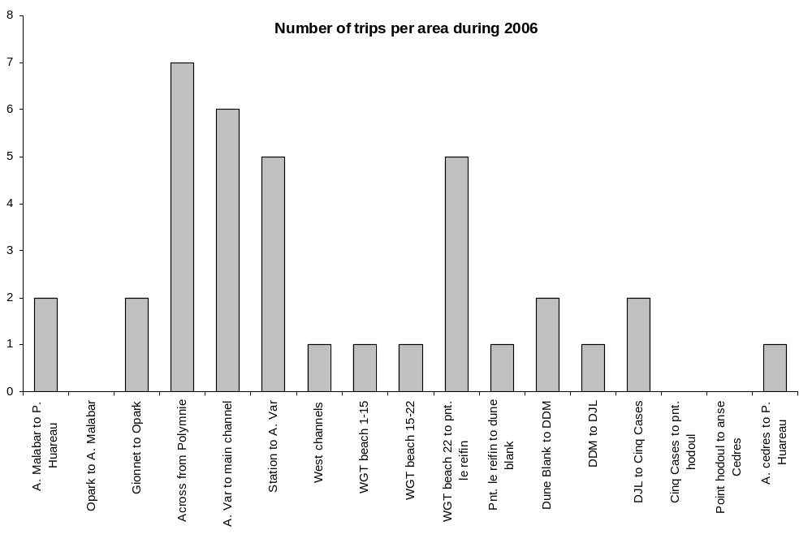
Fig. 17. Distribution of fishing effort around Aldabra in 2006.

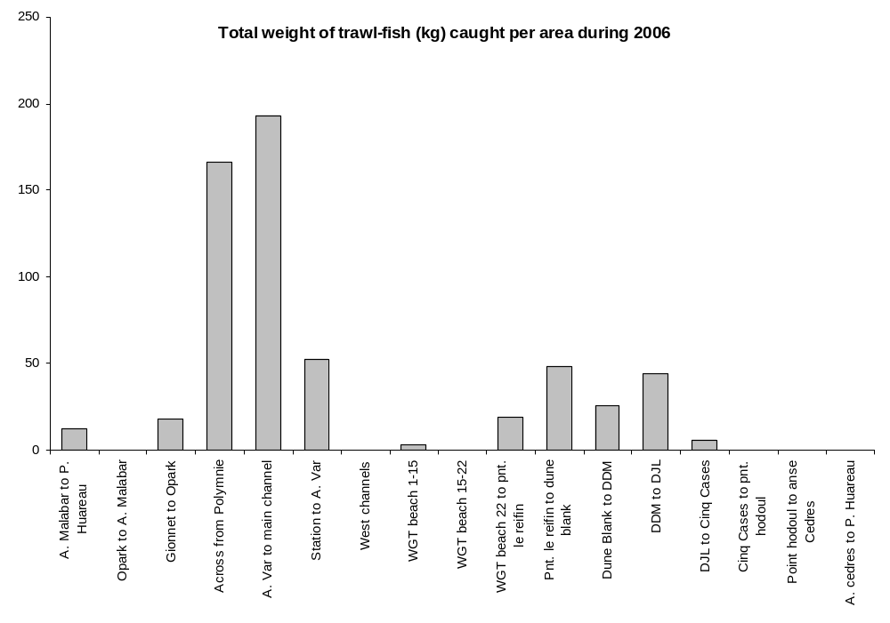
Fig. 18. Total weight of trawl fish caught at various locations around Aldabra in 2006.

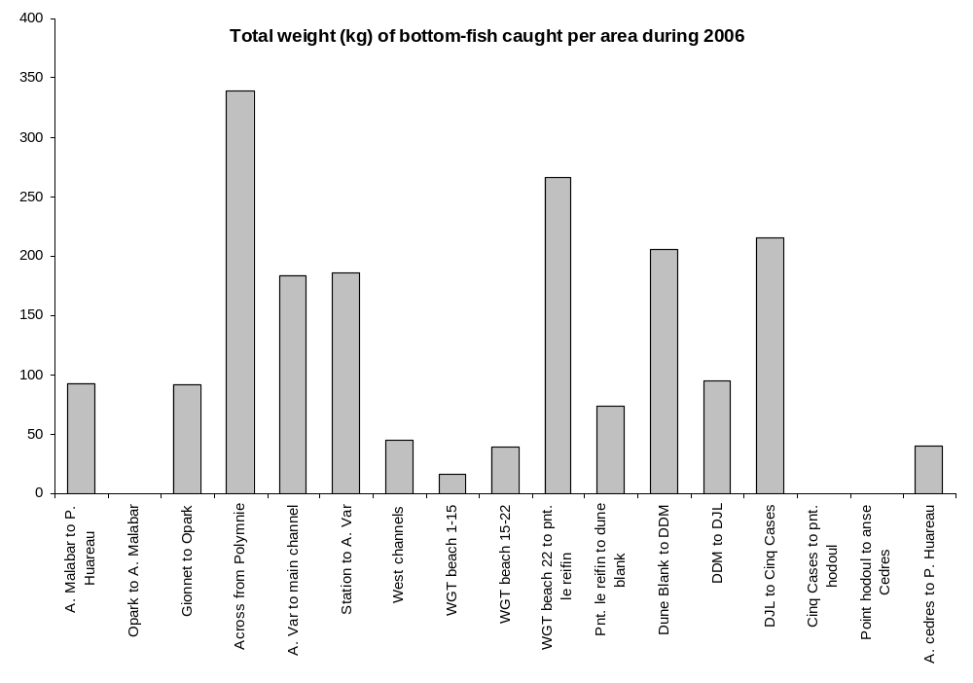
Fig. 19. Total weight of bottom fish caught at various locations around Aldabra in 2006.

6. Robber crabs

A study on robber crabs commenced in October this year with the aim of determining the following:

- Changes in apparent abundance of coconut crabs in relation to season
- Relative densities of coconut crabs in different vegetation types, in relation to distance from the coast, and between the four main islands of Aldabra Atoll
- Absolute population estimate for Aldabra Atoll
- Population structure of the coconut crab on Aldabra
- Relative growth rates in relation to vegetation type
- Movement patterns within Picard Island

Close on weekly counts of coconut crabs have been made on the Picard back path and the coastal path, usually both transects covered between 20h00 and 23h00. During some monthly visits to camps around the atoll searches were also made around the hut and in some cases along existing transects for robber crabs (Table 8). Each crab encountered (520 in total) was weighed and carapace length measured. Moult status, in other words relative duration since last moult, was also estimated by the sharpness of the dactyls on the front legs which wear down with time (Table 9). During the onset of the study several other morphometric measurements were also taken to see what one correlates the best with weight. The sex of each crab is determined during encounter and for the latter part of the study individuals have been marked with a permanent marker pen on the inside of the claw. This area is generally not exposed or dragged and from recaptured it is evident that these marks last at least 8 weeks. This is a long enough period to determine movement patterns (by recording the point of initial and recapture along these transects) and weight gain from recaptured individuals.

Table 8. Number of coconut crabs marked and number of coconut crabs resighted at various study sites around the atoll.
Area | Marked | Resights | Total
Anse Mai | 61 |  | 61
Cinq Cases Circular | 5 |  | 5
Cinq Cases Cocos | 7 |  | 7
Cinq Cases Hut | 44 | 7 | 51
Malabar Hut | 65 |  | 65
Picard Back Path | 113 | 8 | 121
Picard Coastal Path | 157 | 8 | 165
Research Station | 45 |  | 45
Total | 497 | 23 | 520

Table 9. Description of moult status codes assigned
Code | Name | Description
1 | newly moulted | dactyl is needle-sharp, lots of new hairs present
2 | recent moult | dactyl looks sharp but doesn't prick the skin, new hairs present
3 | old moult | dactyl blunt, worn hairs present
4 | very old moult | dactyl very blunt or absent, no hairs present

Some preliminary results follow from the limited data collected. A significant relationship between moult status and the ratio of carapace length to weight was apparent (Fig. 20). This relationship is intuitive seeing that the carapace in crustaceans do not grow between moults but weight is gained. A good relationship was similarly present between carapace length and body weight (Fig. 21).

y = -0.0279x + 0.155
R
2
= 0.3012, p < 0.05
0.00
0.05
0.10
0.15
0.20
0.25
0.30
0.35
0.40
0
1
2
3
4
5
Moult status code
Fig. 20. Relationship between moult status and the ratio of carapace length to body weight in robber crabs at Aldabra.

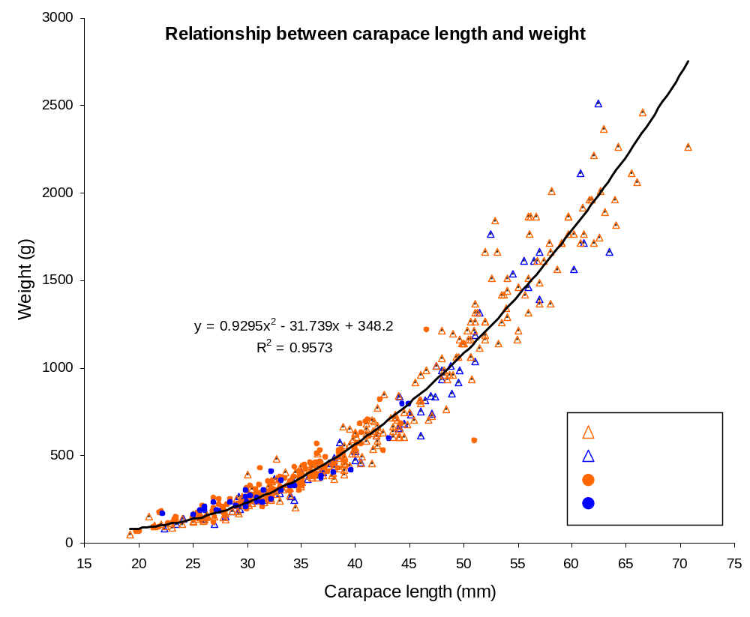
Fig. 21. Relationship between carapace length and weight in robber crabs at Aldabra.

The weight distribution of robber crabs showed substantial variation according to locality (Fig. 22). The largest individuals were encountered close to the Cinq Cases hut. At all localities the 400 grams weight class were the most abundant. Very few individuals reach more than 2.5kg in weight.

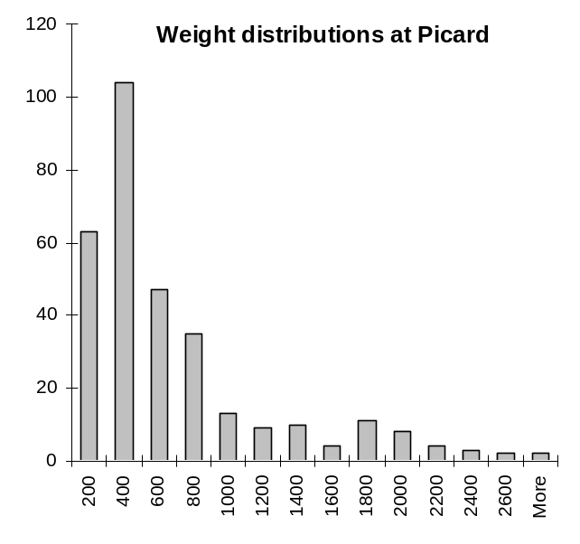
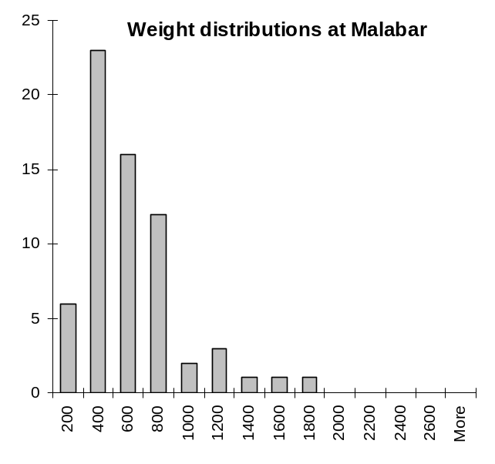
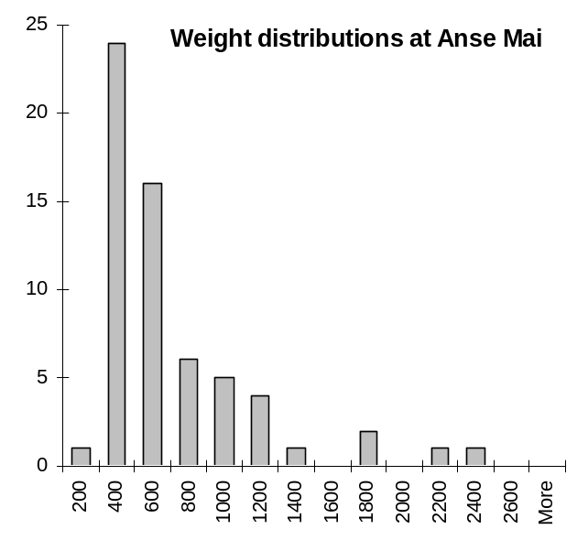
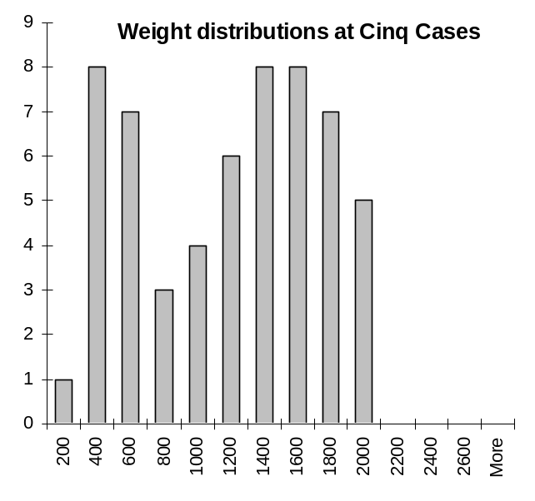
Fig. 22. Weight (grams) distribution of robber crabs around Aldabra.

7. Marine mammals

The first humpback whale for the year was seen on the 9th of July and the last one on the 15th of November. A total of 21 sightings of these whales were reported within this period. Large groups (about 30 and 50) of short-finned pilot whales were observed on two occasions. Spinner dolphins were regularly sighted and occasionally bottlenose dolphins but these sightings were seldom reported.

Dugongs were only sighted twice during the course of 2006 compared to six sightings in 2005. This difference could partly be attributable to the FIB not having been in commission during 2006.

8. Climate

Aldabra had an exceptionally high rainfall in 2006, largely a result of high rainfall in January, February, March and December (Fig. 23). An annual rainfall of 1787mm was recorded for the year compared to 1080 in 2005 and an average of 741 for the period 2000 to 2005 (Fig. 24). Fig. 25 was taken from a previous research officer’s report (Anna Liljevik) and she compiled annual rainfall figures for the period 1949-2001. Rainfall figures were sourced from Stoddard and Walsh (1979), ERGO (1997) and more recently, station records. From this figure it is clear that 1787 mm is the most rainfall per annum that Aldabra has experienced since 1949 with the only other year approximating this amount being 1981.

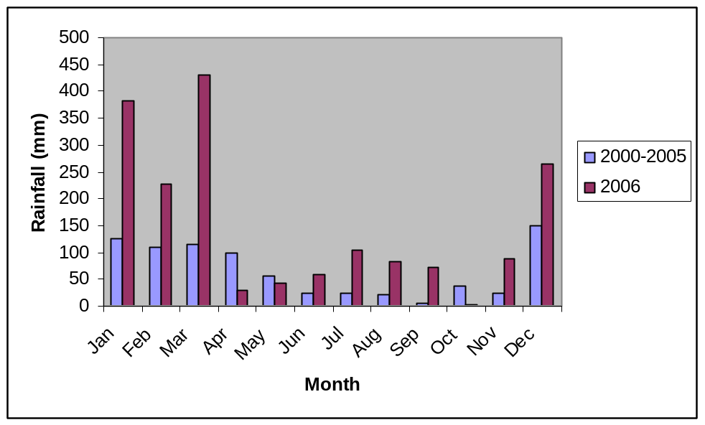
Fig 23. Monthly rainfall measured at the research station on Aldabra for 2006 and the average of measurements taken between 2000 and 2005.

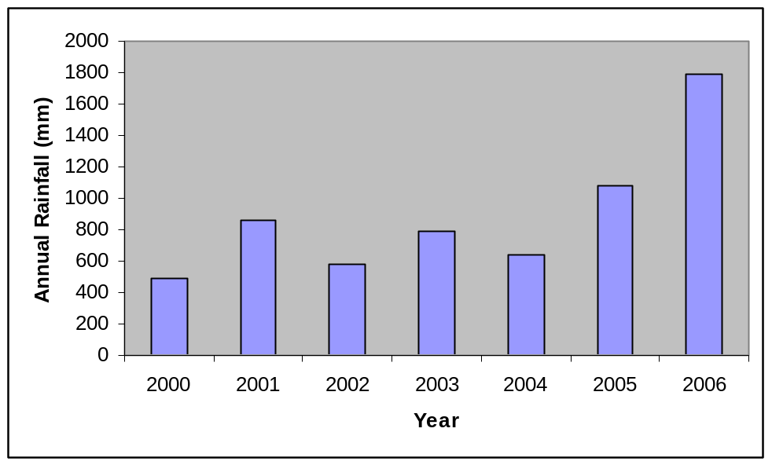
Fig 24. Total annual rainfall at the research station on Aldabra for the period 2000-2006.

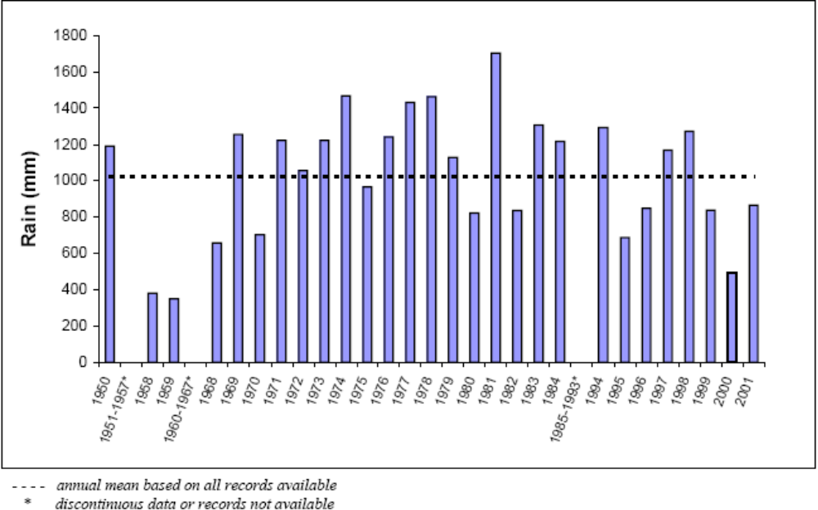
Fig. 25. Total annual rainfall recorded at Aldabra station between 1950 and 2001. The 1949-1984 dataset was obtained from Aldabra revisited (ERGO 1997) and the 1994-2001 dataset from records on Aldabra.

Annual rainfall figures from the 12 rainfall gauges around the atoll are presented in Fig. 26. Several of these overflowed during the course of the year and this could account for none of these measuring up to the annual rain measurement from the station. Most variation of measurements around the Atoll is a result of localized rainfall patterns. Some discrepancies can, however, be attributed to the rain gauges only being checked monthly and at different times of the month. All of the outstation measurements therefore include some and variable amounts of rainfall from December 2005 (measured in the January reading) and not all of the rainfall in December 2006.

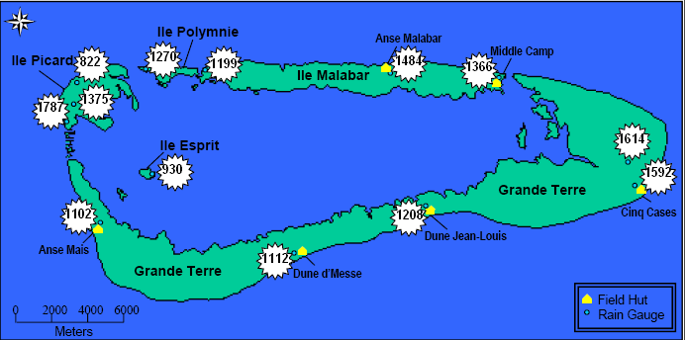
Fig. 26. Annual rainfall figures for the 12 rainfall gauges around Aldabra Atoll and at the research station for 2006.

Monthly temperature readings from the station are provided in Table 8. Interestingly mean annual dry bulb temperature for 2006 was the lowest experienced thus far this decade (Fig. 27). This could possibly be associated with the high rainfall experienced during the year.

Table 8. Mean monthly temperatures measured at Aldabra Station during 2006
 | Jan | Feb | Mar | Apr | May | Jun | Jul | Aug | Sep | Oct | Nov | Dec | Average
Mean dry bulb (Cº) | 27.6 | 27.5 | 27.9 | 27.7 | 27.1 | 25.6 | 23.0 | 24.2 | 24.7 | 25.9 | 27.3 | 26.8 | 26.3
Mean wet bulb (Cº) | 26.6 | 26.9 | 27.1 | 27.0 | 26.3 | 24.4 | 23.0 | 23.1 | 23.7 | 24.5 | 26.4 | 26.4 | 25.5
Mean Max (Cº) | 31.1 | 31.1 | 31.6 | 31.9 | 31.0 | 29.0 | 29.5 | 29.5 | 29.5 | 30.0 | 31.6 | 32.9 | 30.7
Mean Min (Cº) | 25.4 | 25.0 | 26.0 | 26.0 | 25.4 | 24.0 | 23.5 | 22.7 | 23.0 | 24.2 | 25.5 | 24.4 | 24.6

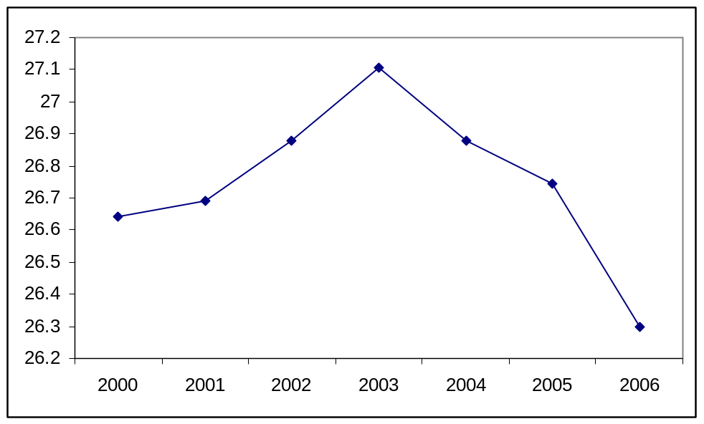
Fig. 27. Mean monthly dry bulb temperatures at Aldabra station for 2006.

9. References

Bourn. D., Gibson., Augeri. D., Wilson. C., Church. J., Hay. S., 1999. The rise and fall of the Aldabran giant tortoise population. Proc. R. Soc. Lond. B 266, 1091-1100
Bourn, D., Goodridge, S. 2004. Guide for the Aldabran giant tortoise population monitoring database
ERGO/SIF 1997. Aldabra Revisited: Final report on the 1997 Aldabra giant tortoise and vegetation study. P.89
Liljevik 2002. SIF Research Officer Annual Report (2000-2002).
Mortimer, J.A, 1988. Green turtle nesting at Aldabra Atoll- Population estimates and trends. Biol. Soc. Wash 8: 116-128.
Stoddard, D.R. & Walsh, R.P.D. 1979. Long-term climatic change in the western Indian Ocean. Phil. Trans. R. Soc. Lond. B. 286: 11-23

